**ABSTRACT**

The project aims to discover the best model for crop prediction, which can help farmers to decide the suitable crop to grow based on the nutrients present in the soil. As India is one of the top Agricultural producing Countries in the World and we are mostly dependent on a cultivation which is depending on the soil. There are 3 most important nutrients in any soil, it’s known as the primary macronutrients: Nitrogen (N), Phosphorus (P), and Potassium(K). Each of the primary nutrients is very essential in plant nutrition, serving a critical role in the growth and reproduction of the plant. In this project, we will use K-Nearest Neighbour algorithm. Here the N:P:K values plays a vital role to give the prediction of suitable crops for that particular soil.Machine learning is an important decision support tool for crop prediction, including supporting decisions on what crop to grow in the soil.

**CHAPTER 1**

**INTRODUCTION**

For most non-industrial nations, agribusiness is their essential wellspring of income. Present day horticulture is a continually developing methodology for rural advances and cultivating procedures. It becomes provoking for the ranchers to fulfill our planet's developing prerequisites and the assumptions for vendors, clients, and so on. A portion of the difficulties the ranchers face is-

1. Supplement lack in the dirt, brought about by a deficiency of vital minerals like potassium, nitrogen, and phosphorus can bring about diminished crop development.
2. (ii) Ranchers commit an error by developing similar harvests for many years without trying different things with various assortments. Agribusiness is the main stockpile of Indian Economy. For the better harvest yield, the ranchers generally require a right yield that can give great yield in that dirt. It is anticipating future potential harvests that can be planted in soil with its separate NPK rates.

**1.1 MOTIVATION**

As we are seeing numerous ranchers committing Suicides these days by developing harvests without knowing the appropriateness of the yield. By taking into account this situation, we dealt with an undertaking which proposed reasonable yield for the dirt. Ranchers are relocating to urban communities in the wake of dealing with numerous issues. Legitimate Use of the accessible assets are getting decreased and most concerning issues looked by ranchers is because of absence of accessibility of Composts, manures, biocides, seeds, apparatuses not with regards to raising harvests.

**1.2 PROBLEM DEFINITION**

Without knowing the N,P,K values of particular crop that grows in the soil, Farmer grow the crop which results in decrease of crop production and crop yield. So in this project, We will find the proper N,P,K values of the soil .Based on that values we suggest the crop for that particular soil ,So that the crop yield and crop production increases.

**1.3 OBJECTIVE OF THE PROJECT**

* The primary goal of this study is to examine, evaluate and identify the suitable crop using trained modelspresent in the dataset.
* And this model increases the accuracy in detecting the prediction of crop by using KNN Algorithm.

**1.4 LIMITATIONS OF PROJECT**

* lack of practical knowledge of farmers
* We will detect only the nitrogen, potassium and phosphate present in the soil. Parameters like humidity, pressure, pH are not identified.

**1.5 ORGANIZATION OF THE DOCUMENT**

* Chapter 2 is Literature Survey which emphasizes the related works and their disadvantages.
* Chapter 3 deals with Requirements and Analysis.
* Chapter 4 deals with the design.
* Chapter 5 deals with the Implementation and result of the Project.
* Chapter 6 deals with Testing and Validation.
* Chapter 7 deals with the Conclusion and Future work.

**CHAPTER 2**

**LITERATURE REVIEW**

**2.1 INTRODUCTION**

To decrease crop failures and predict the best crops for farmers by using the latest technologies to give the best accuracy rates and good crop yielding we need to go through the different scenarios and test cases to give the best outcome.

**2.2 LITERATURE SURVEY**

In the research conducted by the Nischitha k, Dhanush Vishwakarma, Mahindra N, Ashwini , Manju Raju M.R “ **Crop Prediction System using Machine Learning Approaches** [1]” **.** As we probably are aware the way that, India is the second biggest populace country on the planet and larger part of individuals in India have agribusiness as their occupation. Ranchers are developing same harvests more than once without attempting new verity of yields and they are applying composts in irregular amount without knowing the lacking substance and amount. Thus, this is straightforwardly influencing on crop yield and furthermore causes the dirt fermentation and harms the top layer. In this way, we have planned the framework utilizing AI calculations for advancement of ranchers. Our framework will propose the best appropriate harvest for specific land in view of content and climate boundaries. And furthermore, the framework gives data about the expected substance and amount of composts, required seeds for development. Consequently, by using our framework ranchers can develop another assortment of harvest, may increment in net revenue and can stay away from soil contamination.

In the research conducted by the Mayank Chempaneri, Chaitanya Chandvidhkar, Darpan Chachpara, Mansing Rathod “**CROP YIELD PREDICTION USING MACHINE LEARNING** [2]”. The effect of environmental change in India, the greater part of the farming yields are by and large seriously impacted with regards to their presentation over a time of the most recent twenty years. Foreseeing the harvest yield ahead of its gather would help the strategy producers also, ranchers for going to suitable lengths for promoting and stockpiling. This undertaking will assist the ranchers with knowing the yield of their harvest prior to developing onto the farming field and subsequently assist them with pursuing the fitting choices. It endeavors to tackle the issue by building a model of an intuitive expectation framework. execution of such a framework with a simple to-utilize online realistic UI and the AI calculation will be done. The aftereffects of the forecast will be made accessible to the rancher. In this way, for such sort of information examination in crop expectation, there are various strategies or calculations, and with the assistance of those calculations we can foresee crop yield. Irregular woods calculation is utilized. By examining this large number of issues and issues like climate, temperature, dampness, precipitation, dampness, there could be no appropriate arrangement and innovations to conquer what is happening looked by us. In India, there are numerous ways of expanding the financial development in the field of agribusiness. Information digging is likewise valuable for anticipating crop yield creation. By and large, information mining is the method involved with investigating information from different perspective and summing up it into significant data. Irregular timberland is the most famous and strong regulated AI calculation fit for performing both characterization and relapse errands, that work by building a huge number of choice trees during preparing time and creating result of the class that is the method of the classes (characterization) or mean expectation (relapse) of the singular trees.

In the research conducted by the S.P raja, Barbara Sawicka, Zoran Stankovic “**Crop Prediction Based on Characteristics of the Agricultural Environment Using Various Feature Selection Techniques and Classifiers**[3]”. Farming is a developing field of exploration. Specifically, crop expectation in agribusiness is basic also, is chiefly dependent upon soil and climate conditions, including precipitation, mugginess, and temperature. Previously, ranchers had the option to settle on the harvest to be developed, screen its development, and decide when it very well may be gathered. Today, in any case, quick changes in natural circumstances have made it difficult for the cultivating local area to keep on doing as such. Subsequently, lately, AI procedures have assumed control over the errand of expectation, and this work has utilized a few of these to decide crop yield. To guarantee that a given AI (ML) model works at an elevated degree of accuracy, it is basic to utilize efficient highlight choice strategies to processor the crude information into an effectively processable AI agreeable dataset. To decrease redundancies and make the ML model more exact, just information includes that have a significant level of significance in deciding the final result of the model should be utilized. Consequently, ideal component choice emerges to guarantee that main the most important highlights are acknowledged as a piece of the model. Conglomerating each and every element from crude information without checking for their job during the time spent causing the model will to superfluously confuse our model. Moreover, extra elements which contribute essentially nothing to the ML model will expand now is the ideal time and space intricacy and influence the precision of the model's result. The outcomes portray that a group strategy offers preferable expectation exactness over the current classification procedure.

***Include author name as above paragraph for the remain below.***

**A Crop Growth Prediction Model Using Energy Data Based on**

**Machine Learning in Smart Farms**

In the new past, the horticultural business has quickly digitalized as savvy ranches through the wide use of information examination and artificial knowledge. Normally, high working costs in a savvy ranch are fundamentally due to client energy use. Therefore, exact assessment of horticultural energy use and natural elements is viewed as one of the significant undertakings for crop development control. e development successions of yields in rural conditions like savvy ranches are connected with horticultural energy utilization and utilization. is concentrate on expects to create and approve a calculation that can decipher the yield development rate reaction to natural and sun powered energy factors in view of AI, and to assess the calculation's precision thought about to the base model. e proposed still up in the air through a near trial of three delegate AI methods, which are irregular timberland (RF), support vector machine (SVM), and slope helping machine (GBM), taking into account the energy utilization for ecological control is exceptionally connected with the paprika crop development. harsh the experiment execution with genuine information assembled from a paprika shrewd ranch in South Korea, the staggered RF can effectively foresee paprika development with a precision of 0.88, taking into account information investigation of variables that utilization sun powered energy. Because of the analysis with the proposed model, the development factors like leaf length, leaf width, and natural elements were found. Besides, the proposed calculation can add to the improvement of utilization through examination of the harvest development large information for different plants in horticultural conditions like a savvy ranch.

**Crop yield prediction using machine learning**

AI is a significant choice help device for crop yield expectation, remembering supporting choices for what harvests to develop and what to do during the developing time of the yields. A few AI calculations have been applied to help crop yield expectation research. In this review, we played out a Precise Writing Audit (SLR) to separate and combine the calculations and elements that have been utilized in crop yield expectation studies. In light of our hunt standards, we recovered 567 applicable examinations from six electronic data sets, of which we have chosen 50 examinations for additional examination utilizing consideration and rejection measures. We examined these chose concentrates cautiously, dissected the strategies and elements utilized, and gave ideas to additional exploration. As per our examination, the most utilized highlights are temperature, precipitation, and soil type, and the most applied calculation is Counterfeit Brain Organizations in these models. After this perception in light of the nalysis of AI based 50 papers, we played out an extra pursuit in electronic data sets to distinguish profound learning-based examinations, arrived at 30 profound learning-based papers, and separated the applied profound learning calculations. As per this extra investigation, Convolution Brain Organizations (CNN) is the most broadly utilized profound learning calculation in these examinations, and the other generally utilized profound learning calculations are Long-Momentary Memory (LSTM) and Profound Brain Organizations (DNN).

**Crop Yield Prediction using Machine Learning Algorithms**

Agribusiness is factor which, first and foremost, is significant for endurance. AI (ML) could be an essential viewpoint for procuring genuine world and usable answer for crop yield issue. Taking into account the current framework including manual counting, environment shrewd bug the executives and satellite symbolism, the outcome got aren't exactly precise. This paper centers fundamentally around foreseeing the yield of the harvest by applying different AI methods. The classifier models utilized here incorporate Calculated Relapse, Innocent Bayes and Arbitrary Backwoods, out of which the Irregular Woodland gives most extreme exactness. The forecast made by AI calculations will assist the ranchers with coming to a choice which harvest to develop to incite the most yield by considering factors like temperature, precipitation, region, and so on. This overcomes any barrier among innovation and farming area.

**Crop Prediction using Machine Learning Approaches**

Horticulture is one of the significant occupation rehearsed in India. It is he broadest monetary area and assumes a most significant part in the general improvement of the country. Over 60% of the land in the nation is utilized for horticulture to do the trick the necessities of 1.3 billion individuals Subsequently taking on new farming advancements is vital. This will be drives the ranchers of our country towards benefit [1]. Earlier harvest forecast and yield expectation was performed based on ranchers experience on a specific area. They will lean toward the earlier or neighborhood or more pattern crop in the encompassing area just for their territory and they need more of information about soil supplements content like nitrogen, phosphorus, potassium in the land. Being what is happening without the revolution of the harvest and apply a lacking measure of supplements to soil it prompts diminish in the yield and soil contamination (soil fermentation) and harms the top layer. Taking into account this large number of issues considers we planned the framework utilizing an AI for improvement of the rancher. Machine learning(ML) is a distinct advantage for horticulture area. AI is the piece of man-made consciousness, has arisen along with bigdata advancements and superior execution registering to set out new open doors for information concentrated science in the multi-disciplinary agri-innovation space. In the Farming field AI for example is definitely not a puzzling stunt or enchantment, it is a bunch of well characterize model that gather explicit information and apply explicit calculations to accomplish expected results [7]. The planned framework will suggest the most appropriate harvest for specific land. In light of climate boundary and soil content like Precipitation, Temperature, Stickiness and pH. They are gathered from V C Homestead Mandya, Government site and climate office. The framework takes the expected contribution from the ranchers or sensors like Temperature, Moistness and pH. This all sources of info information applies to AI prescient calculations like Help Vector Machine (SVM) [5] and Choice tree [6] to distinguish the example among information and afterward process it according to enter conditions. The framework suggests the harvest for the rancher and furthermore prescribes how much supplements to be add for the anticipated yield. The framework has some other detail like showing approximated yield in q/section of land, required seed for development in kg/section of land and the market cost of the harvest.

**Crop Yeild Prediction using Machine Learning Approach**

The effect of environmental change in India, the vast majority of the rural harvests are by and large seriously impacted with regards to their exhibition over a time of the most recent twenty years. Anticipating the yield ahead of its collect would help the approach creators and ranchers for going to proper lengths for showcasing and stockpiling. This task will assist the ranchers with knowing the yield of their harvest prior to developing onto the agrarian field and hence assist them with settling on the suitable choices. It endeavour’s to tackle the issue by building a model of an intuitive expectation framework. Execution of such a framework with a simple to-utilize electronic realistic UI and the AI calculation will be completed. The consequences of the expectation will be made accessible to the rancher. Accordingly, for such sort of information examination in crop expectation, there are various methods or calculations, and with the assistance of those calculations we can anticipate crop yield. Arbitrary backwoods calculation is utilized. By breaking down this multitude of issues and issues like climate, temperature, dampness, precipitation, dampness, there could be no legitimate arrangement and innovations to conquer what is going on looked by us. In India, there are numerous ways of expanding the monetary development in the field of agribusiness. Information digging is likewise valuable for anticipating crop yield creation. By and large, information mining is the most common way of dissecting information from different perspective and summing up it into significant data. Irregular backwoods is the most famous and strong directed AI calculation fit for performing both characterization and relapse errands, that work by developing a large number of choice trees during preparing time and creating result of the class that is the method of the classes (grouping) or mean expectation (relapse) of the singular trees.

**Crop Yield Prediction using Machine Learning Algorithms**

Unique Farming is factor which, first and foremost, is significant for endurance. AI (ML) could be a critical viewpoint for procuring genuine world and usable answer for crop yield issue. Considering the current framework including manual counting, environment shrewd vermin the executives and satellite symbolism, the outcome got aren’t truly precise. This paper centre’s principally around anticipating the yield of the harvest by applying different AI procedures. The classifier models utilized here incorporate Calculated Relapse, Naive Bayes and Irregular Backwoods, out of which the Arbitrary Woods gives most extreme exactness. The forecast made by AI calculations will assist the ranchers with coming to a choice which harvest to develop to initiate the most yield by considering factors like temperature, precipitation, region, and so on. This overcomes any barrier among innovation and farming area.

**A Machine Learning model for Crop and Fertilizer recommendation**

India is right now the world's second biggest maker of a few dry organic products, farming based material crude materials, roots and tuber crops, beats, cultivated fish, eggs, coconut, sugarcane and various vegetables. India is positioned under the world's five biggest makers of more than 80% of horticultural produce things, including many money yields like espresso and cotton. Ranchers are developing same yield in the season as opposed to developing various assortments in different seasons, likewise, applying more amount of composts without knowing genuine items and amount. So we have planned a suggestion model in view of AI , portrays the best appropriate harvest to be developed and compost to be cultivated relying upon soil and climate conditions. Thus by using our system, farmers can develop new harvests in various seasons and advantage a superior benefit, stay away from soil contamination.

**Prediction of Crop Yield and Fertilizer Prediction using ML Algorithms**

Farming is the larger part type of revenue for some individuals in the Indian subcontinent as well as around the world and consequently shapes the foundation of the economy. Present-day challenges like eccentricity in atmospheric conditions, water shortage, and unpredictability because of interest supply vacillations make the requirement for the rancher to be outfitted with advanced methods. All the more explicitly, points like less yield of harvests because of flighty environment, broken water system assets, and soil fruitfulness level consumption s should be conveyed. Subsequently there is a necessity to change the plentiful horticulture information into cutting edge innovations and make them helpfully open to ranchers. A method that can be executed in crop yield expectation is AI. Various AI strategies like relapse, bunching, grouping and expectation can be utilized in crop yield determining. Calculations like Guileless Bayes, support vector machines, choice trees, straight and strategic relapse, and fake brain organizations can be utilized in the forecast. The wide exhibit of accessible calculations represents a determination problem regarding the chose crop. The reason for this study is to examine the way in which different AI calculations might be utilized to figure farming creation and present a methodology with regards to large information processing for crop yield expectation and manure suggestion utilizing AI procedures.

**Crop and Fertilizer Recommendation system using Machine Learning**

India being a farming nation, its economy transcendentally relies upon agribusiness yield development and Argo-industry items. Information Mining is an arising research field in crop yield examination. Yield expectation is a very significant issue in farming. Any rancher is keen on realizing how much yield he is going to anticipate. Investigate the different related ascribes like area, pH esteem from which alkalinity of the not entirely settled. Alongside it, rate of supplements like Nitrogen (N), Phosphorous (P), and Potassium (K) Area is utilized alongside the utilization of third- party applications like APIs for climate and temperature, sort of soil, supplement worth of the dirt around there, sum of precipitation in the area, soil arrangement still up in the air. This multitude of properties of information will be investigated, train the information with different reasonable AI calculations for making a model. The framework accompanies a model to be exact and precise in anticipating crop yield and convey the end client with legitimate proposals about required compost proportion in view of boar metrical and soil boundaries of the land which upgrade to build the harvest yield and increment rancher income.

**Crop Yield Prediction using Deep Neural Networks**

Crop yield is a profoundly still up in the air by numerous variables like genotype, climate, and their connections. Exact yield forecast requires essential comprehension of the practical connection among yield and these intuitive variables, and to uncover such relationship requires both far reaching datasets and strong calculations. In the 2018 Syngenta Harvest Challenge, Syngenta delivered a few enormous datasets that recorded the genotype and yield exhibitions of 2,267 maize mixtures established in 2,247 areas somewhere in the range of 2008 and 2016 and requested that members foresee the yield execution in 2017. As one of the triumphant groups, we planned a profound brain organization (DNN) move toward that exploited cutting edge displaying and arrangement procedures. Our model was found to have a predominant expectation exactness, with a root-mean-square-mistake (RMSE) being 12% of the typical yield and half of the standard deviation for the approval data set utilizing anticipated climate information. With amazing climate information, the RMSE would be diminished to 11% of the typical yield and 46% of the standard deviation. We likewise performed highlight choice in light of the prepared DNN model, which effectively diminished the element of the info space without huge drop in the forecast exactness. Our computational outcomes proposed that this model essentially outflanked other well known strategies like Rope, shallow brain organizations (SNN), and relapse tree (RT). The outcomes likewise uncovered that ecological element greatly affected the harvest yield than genotype.

**Crop Prediction based on soil and environmental Characteristics using Feature Selection Techniques**

Prior, crop development was embraced based on ranchers' active mastery. Not with standing, environmental change has started to influence crop yields gravely. Thus, ranchers can't pick the right harvest/s in light of soil and ecological variables, and the course of physically anticipating the decision of the right yield/s of land has, as a general rule, brought about disappointment. Precise yield forecast brings about expanded crop creation. This is where AI assuming a significant part in the space of harvest expectation. Crop forecast relies upon the dirt, geographic and climatic characteristics. Choosing fitting ascribes for the right harvest/s is an inherent piece of the expectation attempted by include determination methods. In this work, a near investigation of different covering highlight choice techniques are done for crop expectation utilizing characterization procedures that recommend the reasonable harvest/s for land. The exploratory outcomes show the Recursive Component Disposal strategy with the Versatile Stowing classifier beats the others.

**2.3 EXISTING SYSTEM**

In Existing system, the crop prediction is done based on PH values of soil and uses CNN algorithm approaches to build the model. There will be a change in the accurate prediction if we use PH values.

**2.4 DRAWBACKS OF EXISTING SYSTEM**

* There will be change in PH values due to Rainfall. So, the prediction may get wrong.
* It analyses and detect the soil PH through soil image if the image quality is poor then there will be problem in recognizing of soil PH value.

**2.5 PROPOSED SYSTEM**

The proposed system uses N, P, K values to predict the suitability of the crop for the soil. Machine learning is the latest technology which python programming language gives advantage in using various algorithms for crop yield prediction based on the input data set. In this process KNN classification algorithm is used for prediction. In this project testing, training is performed on given text dataset which includes N, P, K values as features and type of crop as labels.

**2.6 ADVANTAGES OF PROPOSED SYSTEM**

* Crop yield prediction is performed based on textual dataset and any user can check type of crop best suits for conditions and get crop suggestions.
* Quick Calculation time
* Versatile-useful for classification and Regression
* Low chance for getting fake.

**CHAPTER 3**

**REQUIREMENTS AND ANALYSIS**

**3.1 INTRODUCTION**

Agribusiness is considered as an import field all around the existence where there are many difficulties in tackling issues during the time spent assessing crops in view of the circumstances. This has turned into a test for non-industrial nations. Utilizing most recent innovations many organizations are utilizing IOT based administrations and Mechanical innovation to lessen manual work. These techniques are for the most part helpful for the situation on decreasing manual work yet not in expectation process. In this task crop yield expectation utilizing AI most recent ML innovation and KNN order calculation is utilized for expectation crop yield considering soil and temperature factors. Dataset is ready with different soil conditions as elements and names for anticipating kind of each mark is connected with specific harvest. In expectation process client can give input as soil elements and result will be sort of harvest reasonable for explicit circumstances and application additionally assists in proposing with outmaneuvering crops.

**3.2 REQUIREMENT SPECIFICATIONS**

**3.2.1 HARDWARE DESCRIPTION**

* Processor - Intel 486/Pentium processor or better
* Processor Speed - 500 MHz or above
* Hard Disk - 20GB(approx.)
* RAM - 64MB or above

**3.2.2** **SOFTWARE DESCRIPTION**

* Operating System : Windows 8 and above
* Language : Python
* Libraries : NumPy
* Platform : Google COLAB

**3.2.3 LANGUAGE SPECIFICATION**

Python is a major area of strength for a simple to-pick up programming language. It has proficient significant level information structures and an article situated programming method that is straightforward however successful. Python's lovely sentence structure and dynamic composing, as well as its deciphered nature, make it a great language for prearranging and speedy application improvement across a large number of stages. The Python mediator and complete standard library are openly open for all significant stages in source or parallel structure from the Py Site, https://www.python.org/, and might be made accessible. Its equivalent site likewise has connections to and arrivals of an assortment of free Python modules, scripts, and devices, as well as additional documentation. New capabilities and information types written in C or C++ can essentially be added to the Python translator (or different dialects callable from C). Python can likewise be utilized as a stress for programs that can be modified. Python is a prearranging language that is significant level, deciphered, intuitive, and object situated. Python is planned to be a truly justifiable language. It ordinarily utilizes English terms rather than accentuation and has less linguistic designs than different dialects.

**3.2.4 Google Colab**

Google is very forceful in computer-based intelligence research. Over numerous years, Google created a computer-based intelligence system called TensorFlow and an improvement device called Collaboratory. Today TensorFlow is publicly released and beginning around 2017, Google made Collaboratory free for public use. Collaboratory is currently known as Google Colab or basically Colab.

One more appealing element that Google offers to the engineers is the utilization of GPU. Colab upholds GPU and it is free. The explanations behind making it free for public could be to make its product a norm in the scholastics for showing AI and information science. It might likewise have a drawn-out viewpoint of building a client base for Google Cloud APIs which are sold per-use premise. Independent of the reasons, the presentation of Colab has facilitated the learning and improvement of AI applications.

**What Colab Offers You?**

As a programmer, you can perform the following using Google Colab.

Write and execute code in Python.

Document your code that supports mathematical equations.

Create/Upload/Share notebooks.

Import/Save notebooks from/to Google Drive

Import/Publish notebooks from GitHub.

Import external datasets e.g., from Kaggle.

Integrate Py Torch, TensorFlow, Kera’s, OpenCV

Free Cloud service with free GPU.

**3.3 Content diagram of Project**

**CHAPTER 4**

**DESIGN**

**4.1 INTRODUCTION**

Planning any task requires the execution of different compositional outlines. In particular, UML outlines are fundamentally used to plan and dissect projects prior to prototyping and creation. Configuration is a beginning stage of an undertaking where the task's key elements, structure, standards for progress, and significant expectations are arranged out.

**4.2 UML DIAGRAMS**

The UML graphs assist us with understanding and planning the application without any problem. UML is a model-based language for picturing, depicting, constructing, and recording software intensive frameworks. UML gives a standard strategy to compose a framework model that incorporates reasonable thoughts.

**4.2.1 USE CASE DIAGRAM**

At its most essential level, a utilization case chart portrays the boundaries of a utilization case and addresses a client's cooperations. A utilization case chart can portray the different kinds of framework clients and how they speak with it. This style of graph is much of the time utilized regarding a text-based use-case, and it is regularly joined by different charts.

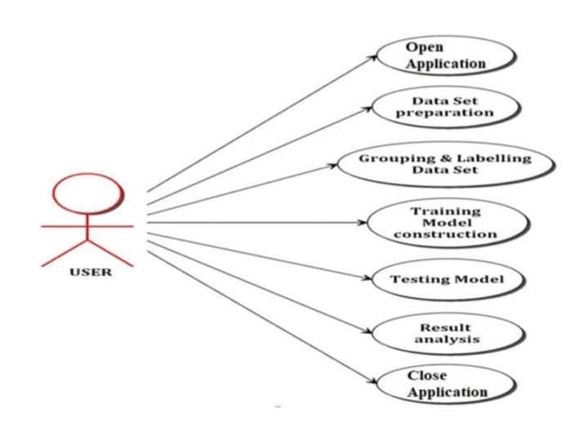

**4.2.2 ACTIVITY DIAGRAM**

Action Charts portray how exercises are facilitated to offer a support which can be at various degrees of reflection. Commonly, an occasion should be accomplished by certain tasks, especially where the activity is expected to accomplish various things that require coordination, or how the occasions in a solitary use case connect with each other, specifically, use situations where exercises might cover and require coordination. It is likewise reasonable for displaying how an assortment of purpose cases direction to address business work processes.

**4.2.2 SEQUENCE DIAGRAM**

A grouping graph is a Brought together Displaying Language (UML) chart that outlines the succession of messages between objects in a cooperation. A succession graph comprises of a gathering of items that are addressed by life savers, and the messages that they trade after some time during the interaction. A grouping outline shows the grouping of messages passed between objects. Succession charts can likewise show the control structures between objects. For instance, helps in a grouping outline for a financial situation can address a client, bank employee, or bank director. The correspondence between the client, teller, and director are addressed by messages passed between them. The arrangement graph shows the items and the messages between the articles.

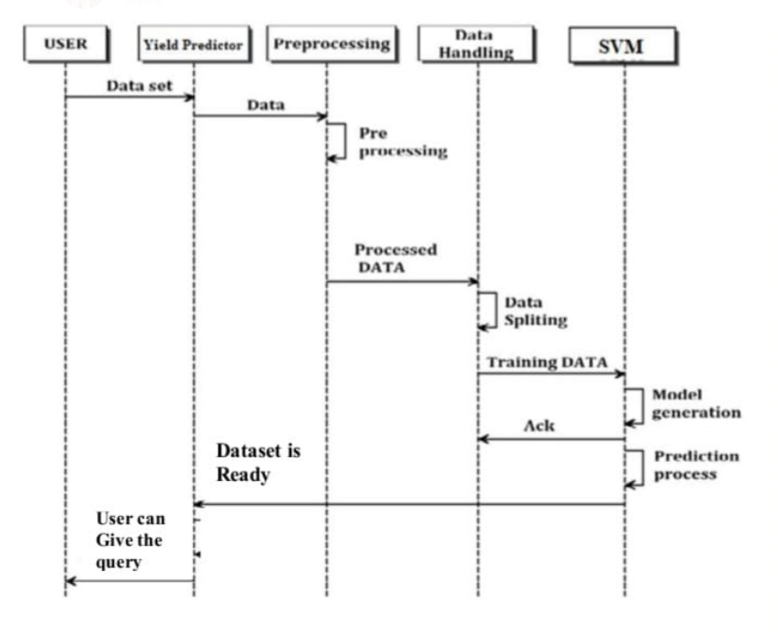

**4.3 Module Design and Organization**

**4.3.1:Model design:**

Plan, or seclusion in plan, is a plan rule that partitions a framework into more modest parts called modules, (for example, measured process slips), which can be freely made, changed, supplanted, or traded with different modules or between various frameworks.

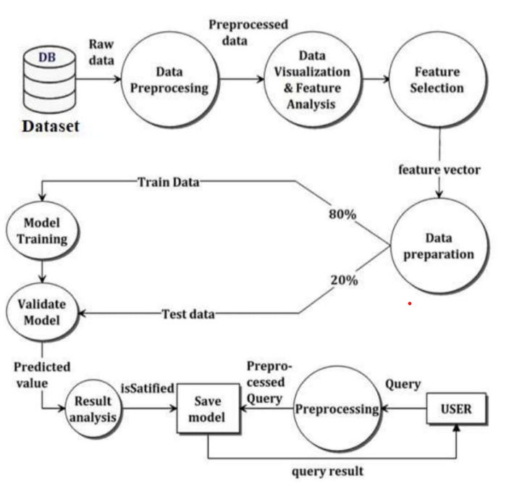

**4.3.2: Module output:**

**Module A**

**Data Collection and Preprocessing**

* Data collection is the most efficient method for collecting and measure the data from different resources.
* To get an estimated dataset for the framework. This dataset should contain the accompanying trait NPK values, those boundaries will consider for crop expectation.
* In the wake of gathering datasets from different assets. Dataset should be pre-processing prior to preparing to the model. The information pre-processing should be possible by different stages, starts with perusing the gathered dataset.
* The cycle proceeds to information cleaning. In information cleaning the datasets contain a few repetitive qualities, those credits are not considering for crop expectation.
* In this way, we need to drop undesirable credits and datasets containing a few missing qualities we really want to drop these missing qualities or load up with undesirable nan values to get better exactness.
* Then define the target for a model.

**Module B**

**Training Model**

* Fetching the data from the Data Sets
* Provide Suitable N:P:K Values for various crops to the machine.
* Training dataset to show which crop will suit the soil best using KNN Algorithm.

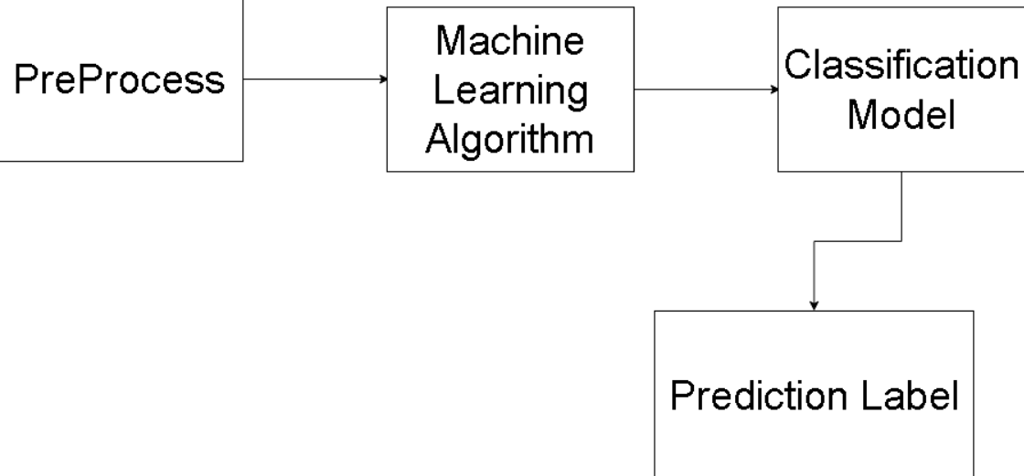

**Module C**

**Testing Model**

* Here user can test and analyse the respective model by performing pre-processing over the input data.
* Mapping to user input using saved featured (based on training dataset). Then feed to saved model for prediction.
* The testing dataset is used to predict the crop to be raised, using the trained classifier.
* Finally, a suitable crop is obtained by using KNN algorithm.

**4.4 Conclusion**

The ongoing framework is fit for anticipating the best reasonable harvest and dividing horticultural assets between the clients.

The framework can be improved by adding numerous datasets and as the client expands the proficiency of the framework increases appropriately. Streamlined equipment can give strength in the real-time situations.

**CHAPTER-5**

**IMPLEMENTATION AND RESULTS**

**5.1 INTRODUCTION**

The work done to satisfy the guidelines of the extent of work is alluded to as the execution stage. The expression "AI" alludes to a technique for perceiving designs in information. During the execution stage, the venture group achieved the errands framed in the arrangement and made any essential updates.

**5.2 IMPLEMENTATION OF KEY FUNCTIONS**

● read csv () from the panda’s package is used to read the data set.

● seaborn library is used for visualizing the data

● Data cleaning functions for removing the anomalies

● The model was built using the KNN Algorithm.

**5.3 Method of Implementation**

**5.3.1 DATA PREPROCESSING**

Information pre-processing is the most common way of adjusting or eliminating information before to its utilization to guarantee or further develop execution. The most common way of getting ready crude information for use in an AI model is known as information pre-processing. It's the most critical and initial phase in making an AI model. While dealing with an AI project, we don't necessarily approach perfect, arranged information. Also, prior to doing any information related movemen t, cleaning the information and arrangement it is essential. Subsequently, we apply the information pre-processing task for this.

**5.3.2 DATA SPLITTING**

The dataset is parted into two sections: a Preparation informational index and a Testing informational index. By and large, the information is separated into two sets, the preparation set and the testing set, utilizing a 8:2 proportion. The preparation informational index is utilized to construct a model, though the test dataset is utilized to decide if the model is correct. Since the information contains 17880 work commercials, 14304 are used to foster a model and 3576 are utilized to approve the model.

**5.3.3 CLASSIFICATION MODEL**

KNN Classification Algorithm is applied on the Training set and based on the test result accuracy, it suggests whether crop suits or not.

* + 1. **IMPLEMENTED MACHINE LEARNING MODELS**

1. **K-Nearest Neighbour(KNN) Algorithm for Machine Learning**

* K-Closest Neighbour is one of the least difficult AI calculations in view of Managed Learning strategy.
* K-NN calculation expects the closeness between the new case/information and accessible cases and put the new case into the class that is generally like the accessible classes.
* K-NN calculation can be utilized for Relapse as well concerning Grouping yet for the most part it is utilized for the Arrangement issues.
* It is likewise called a languid student calculation since it doesn't gain from the preparation set quickly rather it stores the dataset and at the hour of order, it plays out an activity on the dataset.

**Why do we need a K-NN Algorithm?**

Assume there are two classifications, i.e., Classification An and Classification B, and we have another information point x1, so this information point will lie in which of these classes. To take care of this sort of issue, we really want a K-NN calculation. With the assistance of K-NN, we can undoubtedly recognize the classification or class of a specific dataset. Consider the beneath graph:

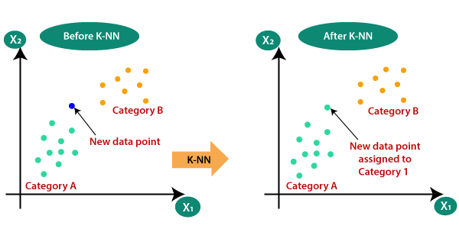

* We utilize Euclidean distance equation for tracking down k number of neighbours
* First and foremost, we will pick the quantity of neighbour’s
* Then, we will ascertain the Euclidean distance between the data of interest. The Euclidean distance is the distance between two focuses, which we have proactively concentrated on in calculation. It tends to be determined as**:**

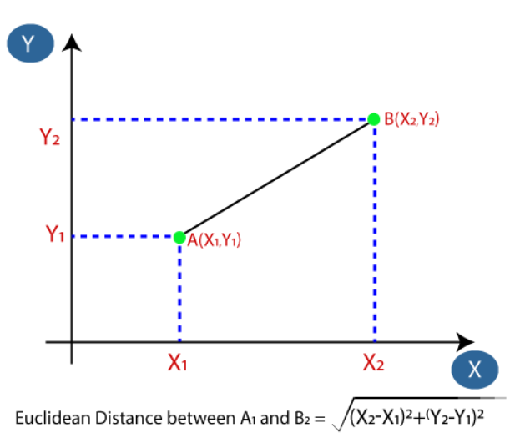

1. **Decision Tree (DT):**

A choice tree is a non-parametric directed learning calculation, which is used for both grouping and relapse errands. It has a various leveled, tree structure, which comprises of a root hub, branches, interior hubs and leaf hubs.

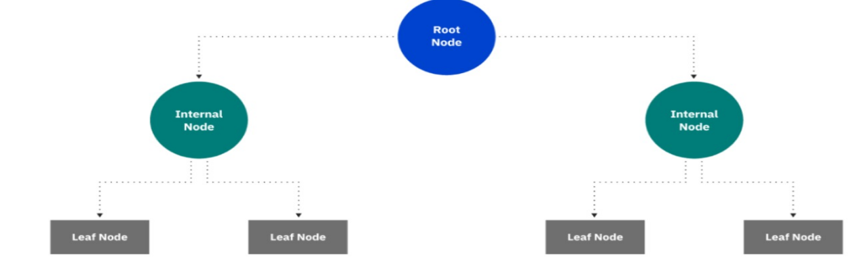

1. **Gradient Boosting Classifier:**

Slope supporting is a strategy standing apart for its expected speed and exactness, especially with enormous and complex datasets. From Kaggle contests to AI answers for business, this calculation has delivered the best outcomes. We realize that blunders assume a significant part in any AI calculation. There are primarily two kinds of blunder, predisposition mistake and fluctuation blunder. Angle support calculation assists us with limiting inclination blunder of the model.

**D)Random Forest Classifier:**

Irregular Woods is a well known AI calculation that has a place with the managed learning method. It tends to be utilized for both Arrangement and Relapse issues in ML. It depends on the idea of gathering realizing, which is a course of joining various classifiers to tackle an intricate issue and to work on the exhibition of the model.

As the name recommends, "Irregular Woodland is a classifier that contains various choice trees on different subsets of the given dataset and takes the normal to work on the prescient precision of that dataset." Rather than depending on one choice tree, the irregular timberland takes the forecast from each tree and in view of the larger part votes of expectations, it predicts the last result.

The more prominent number of trees in the woodland prompts higher precision and forestalls the issue of overfitting.

The below diagram explains the working of the Random Forest algorithm:

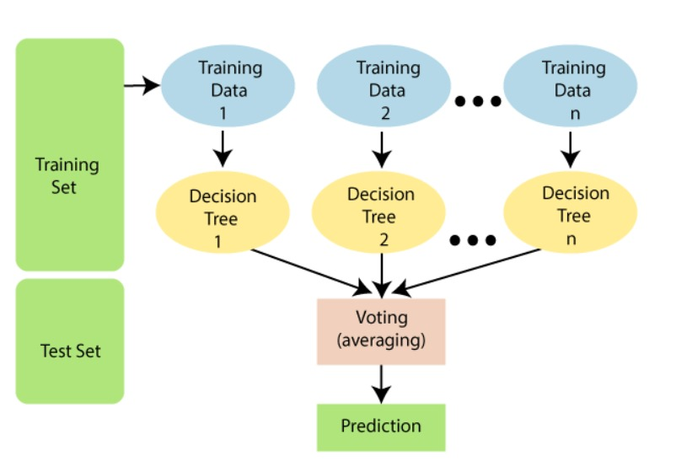

**ACCURACY MEASURED BY DIFFERENT MODELS**

The accuracy compared to the other models the KNN model will give the more accuracy.

* 1. **Output Screens and Result Analysis**

**5.4.1. Source Code:**

import numpy as np

import pandas as pd

# for data visualizations

import matplotlib.pyplot as plt

import seaborn as sns

plt.style.use('fivethirtyeight')

# for interactivity

import ipywidgets

from ipywidgets import interact

import os

data = pd.read_csv("sample1.csv")

# lets check teh shape of the dataset

print("Shape of the Dataset :", data.shape)

data.isnull().sum()

data['label'].value_counts()

print("Average Ratio of Nitrogen in the Soil : {0:.2f}".format(data['N'].mean()))

print("Average Ratio of Phosphorous in the Soil : {0:.2f}".format(data['P'].mean()))

print("Average Ratio of Potassium in the Soil : {0:.2f}".format(data['K'].mean()))

@interact

def summary(crops = list(data['label'].value_counts().index)):

    x = data[data['label'] == crops]

    print("---------------------------------------------")

    print("Statistics for Nitrogen")

    print("Minimum Nitrigen required :", x['N'].min())

    print("Average Nitrogen required :", x['N'].mean())

    print("Maximum Nitrogen required :", x['N'].max())

    print("---------------------------------------------")

    print("Statistics for Phosphorous")

    print("Minimum Phosphorous required :", x['P'].min())

    print("Average Phosphorous required :", x['P'].mean())

    print("Maximum Phosphorous required :", x['P'].max())

    print("---------------------------------------------")

    print("Statistics for Potassium")

    print("Minimum Potassium required :", x['K'].min())

    print("Average Potassium required :", x['K'].mean())

    print("Maximum Potassium required :", x['K'].max())

    print("---------------------------------------------")

## Lets compare the Average Requirement for each crops with average conditions

@interact

def compare(conditions = ['N','P','K']):

    print("Average Value for", conditions,"is {0:.2f}".format(data[conditions].mean()))

    print("----------------------------------------------")

    print("Rice : {0:.2f}".format(data[(data['label'] == 'rice')][conditions].mean()))

    print("Black Grams : {0:.2f}".format(data[data['label'] == 'blackgram'][conditions].mean()))

    print("Banana : {0:.2f}".format(data[(data['label'] == 'banana')][conditions].mean()))

    print("Jute : {0:.2f}".format(data[data['label'] == 'jute'][conditions].mean()))

    print("Coconut : {0:.2f}".format(data[(data['label'] == 'coconut')][conditions].mean()))

    print("Apple : {0:.2f}".format(data[data['label'] == 'apple'][conditions].mean()))

    print("Papaya : {0:.2f}".format(data[(data['label'] == 'papaya')][conditions].mean()))

    print("Muskmelon : {0:.2f}".format(data[data['label'] == 'muskmelon'][conditions].mean()))

    print("Grapes : {0:.2f}".format(data[(data['label'] == 'grapes')][conditions].mean()))

    print("Watermelon : {0:.2f}".format(data[data['label'] == 'watermelon'][conditions].mean()))

    print("Kidney Beans: {0:.2f}".format(data[(data['label'] == 'kidneybeans')][conditions].mean()))

    print("Mung Beans : {0:.2f}".format(data[data['label'] == 'mungbean'][conditions].mean()))

    print("Oranges : {0:.2f}".format(data[(data['label'] == 'orange')][conditions].mean()))

    print("Chick Peas : {0:.2f}".format(data[data['label'] == 'chickpea'][conditions].mean()))

    print("Lentils : {0:.2f}".format(data[(data['label'] == 'lentil')][conditions].mean()))

    print("Cotton : {0:.2f}".format(data[data['label'] == 'cotton'][conditions].mean()))

    print("Maize : {0:.2f}".format(data[(data['label'] == 'maize')][conditions].mean()))

    print("Moth Beans : {0:.2f}".format(data[data['label'] == 'mothbeans'][conditions].mean()))

    print("Pigeon Peas : {0:.2f}".format(data[(data['label'] == 'pigeonpeas')][conditions].mean()))

    print("Mango : {0:.2f}".format(data[data['label'] == 'mango'][conditions].mean()))

    print("Pomegranate : {0:.2f}".format(data[(data['label'] == 'pomegranate')][conditions].mean()))

    print("Coffee : {0:.2f}".format(data[data['label'] == 'coffee'][conditions].mean()))

# lets make this funtion more Intuitive

@interact

def compare(conditions = ['N','P','K']):

    print("Crops which require greater than average", conditions,'\n')

    print(data[data[conditions] > data[conditions].mean()]['label'].unique())

    print("----------------------------------------------")

    print("Crops which require less than average", conditions,'\n')

    print(data[data[conditions] <= data[conditions].mean()]['label'].unique())

plt.rcParams['figure.figsize'] = (15, 7)

plt.subplot(2, 4, 1)

sns.distplot(data['N'], color = 'grey')

plt.xlabel('Ratio of Nitrogen', fontsize = 12)

plt.grid()

plt.subplot(2, 4, 2)

sns.distplot(data['P'], color = 'blue')

plt.xlabel('Ratio of Phosphorous', fontsize = 12)

plt.grid()

plt.subplot(2, 4, 3)

sns.distplot(data['K'], color ='green')

plt.xlabel('Ratio of Potassium', fontsize = 12)

plt.grid()

plt.suptitle('Distribution for Agricultural Conditions', fontsize = 20)

plt.show()

### Data Visualizations

plt.rcParams['figure.figsize'] = (15, 8)

plt.subplot(2, 4, 1)

sns.barplot(data['N'], data['label'])

plt.ylabel(' ')

plt.xlabel('Ratio of Nitrogen', fontsize = 10)

plt.yticks(fontsize = 10)

plt.subplot(2, 4, 2)

sns.barplot(data['P'], data['label'])

plt.ylabel(' ')

plt.xlabel('Ratio of Phosphorous', fontsize = 10)

plt.yticks(fontsize = 10)

plt.subplot(2, 4, 3)

sns.barplot(data['K'], data['label'])

plt.ylabel(' ')

plt.xlabel('Ratio of Potassium', fontsize = 10)

plt.yticks(fontsize = 10)

plt.suptitle('Visualizing the Impact of Different Conditions on Crops', fontsize = 15)

plt.show()

# lets split the Dataset for Predictive Modelling

y = data['label']

x = data.drop(['label'], axis = 1)

print("Shape of x:", x.shape)

print("Shape of y:", x.shape)

from sklearn.model_selection import train_test_split

x_train, x_test, y_train, y_test = train_test_split(x, y, test_size = 0.2, random_state = 0)

print("The Shape of x train:", x_train.shape)

print("The Shape of x test:", x_test.shape)

print("The Shape of y train:", y_train.shape)

print("The Shape of y test:", y_test.shape)

from sklearn.neighbors import KNeighborsClassifier

from sklearn.tree import DecisionTreeClassifier

from sklearn.ensemble import RandomForestClassifier

from sklearn.ensemble import BaggingClassifier

from sklearn.ensemble import GradientBoostingClassifier

from sklearn.ensemble import AdaBoostClassifier

from xgboost import XGBClassifier

import xgboost as xgb

from sklearn.metrics import classification_report

from sklearn.metrics import accuracy_score,confusion_matrix,roc_auc_score

from mlxtend.plotting import plot_confusion_matrix

def evaluator(y_test, y_pred):

# Accuracy:

    print('Accuracy is: ', accuracy_score(y_test,y_pred))

    print('')

    # Classification Report:

    print('Classification Report: \n',classification_report(y_test,y_pred))

    print('Confusion Matrix: \n\n')

    plt.style.use("ggplot")

    cm = confusion_matrix(y_test,y_pred)

    plot_confusion_matrix(conf_mat = cm,figsize=(10,10),show_normed=True)

    plt.title('Confusion Matrix for Logistic Regression', fontsize = 15)

    plt.show()

model_accuracy = pd.DataFrame(columns=['Model','Accuracy'])

models = {

          "KNN" : KNeighborsClassifier(),

          "DT" : DecisionTreeClassifier(),

          'RFC' : RandomForestClassifier(),

          'GBC' : GradientBoostingClassifier(),

          }

for test, clf in models.items():

    clf.fit(x_train, y_train)

    y_pred = clf.predict(x_test)

    acc = accuracy_score(y_test,y_pred)

    train_pred = clf.predict(x_train)

    train_acc = accuracy_score(y_train, train_pred)

    print("\n", test + ' scores')

    print(acc)

    print(classification_report(y_test,y_pred))

    print(confusion_matrix(y_test,y_pred))

    print('*' * 100,"\n")

    model_accuracy = model_accuracy.append({'Model': test, 'Accuracy': acc, 'Train_acc': train_acc}, ignore_index=True)

model_accuracy.sort_values(ascending=False, by = 'Accuracy')

from sklearn.neighbors import KNeighborsClassifier

kn_classifier = KNeighborsClassifier()

kn_classifier.fit(x_train,y_train)

pred_kn = kn_classifier.predict(x_test)

evaluator(y_test, pred_kn)

data.head()

with open('npk.txt') as f:

  datafile = f.readlines()

  npk=[]

for line in datafile:

  if 'n=' in line:

    n=str(line)

    npk.insert(0,line)

  if 'p=' in line:

    npk.insert(1,line)

    p=str(line)

  if 'k=' in line:

    npk.insert(2,line)

    k=str(line)

inputdata = list(map(lambda x: x.replace('n=','').replace('p=','').replace('k=','').replace('\n',''),npk))

print(inputdata)

inarr=[]

print(type(inputdata))

for i in inputdata:

  inarr.append(float(i))

print(inarr)

prediction = kn_classifier.predict((np.array([[inarr[0],

                                       inarr[1],

                                       inarr[2]]])))

print("The Suggested Crop for Given NPK VALUES is :", prediction)

**5.4.2: Graphs:**

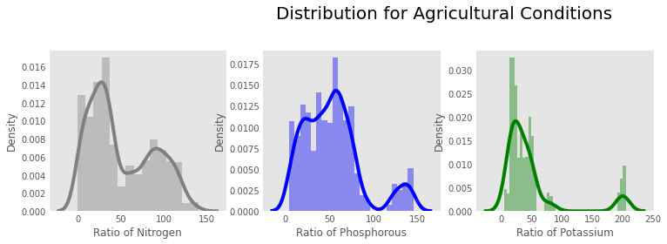

**CLASSIFICATION REPORT AND CONFUSION MATRIX**

**KNN:** **0.6522727272727272**

**Decision Tree:** **0.65**

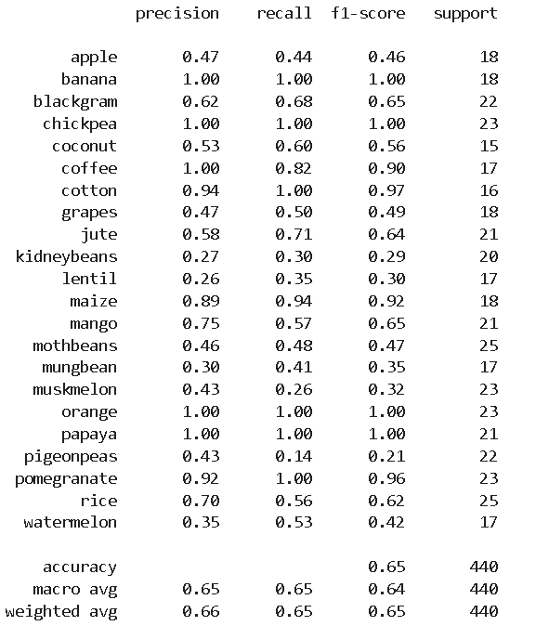

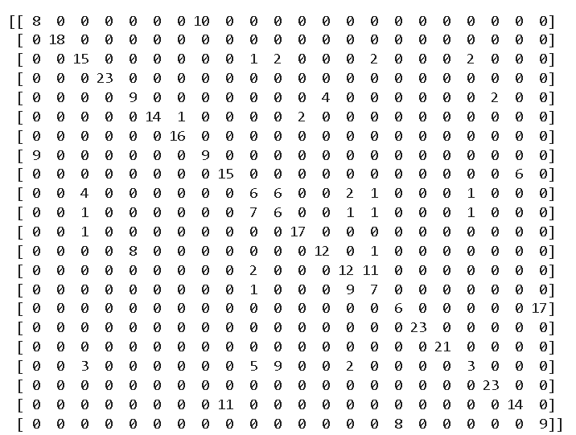

**Gradient Boosting Classifier:** **0.6477272727272727**

**Random Forest Classifier:** **0.6409090909090909**

**5.4.3: OUTPUT:**

**CHAPTER 6**

**TESTING AND VALIDATION**

**6.1 Introduction:**

Testing is a cycle, which uncovers mistakes in the program. It is the main quality measurement utilized in programming improvement. A progression of testcases is utilized to run the application. The result of the program for the experiments is examined to check whether the program is working true to form .To guarantee that the framework doesn't have mistaken, the various degrees of testing systems are applied at contrasting periods of programming advancement**.**

**6.2 TYPES OF TESTING**

**6.2.1 UNIT TESTING**

Unit testing involves making experiments to guarantee that the inward program rationale is working appropriately and that program inputs bring about genuine results. Approval ought to be performed on all choice branches and inside code stream. It inspects the application's singular programming units. It's finished after a unit is done yet before it's incorporated. This underlying testing depends on Information on its development and is intrusive. Unit tests perform fundamental parts and test a particular business cycle, application, and framework design. Unit tests ensure that every individual way of a business interaction follows the distributed particulars and has obviously characterized data sources and results.

**6.2.2 FUNCTIONAL TESTING**

Practical tests show that the capabilities being tried are accessible as per the business and specialized necessities, framework documentation, and client manuals. Practical testing is focused on the accompanying things: Legitimate Info: recognized classes of substantial Info should be acknowledged. Invalid Information: distinguished classes of invalid Information should be dismissed. Capabilities: recognized capabilities should be worked out. Yield: distinguished classes of utilization yields should be worked out. Frameworks: communicating frameworks or systems should be conjured

The association and arrangement of practical tests are centered around prerequisites, key capabilities, or excellent experiments. What's more, methodical inclusion about distinguishing Business process streams, information fields, predefined strategies, and progressive procedures should considered for test. Before useful testing is finished, extra tests are recognized, and the down to earth worth of current still up in the air.

**6.2.3 INTEGRATION TESTING**

Joining tests are intended to test coordinated programming parts to decide whether they run as one program. Testing is occasion driven and is more worried about the essential result of screens or fields. Coordination tests check that, while individual parts were fulfilled, the mix of parts is correct and predictable, as shown by effective unit testing. Reconciliation testing is a sort of testing that spotlights on revealing issues that happen from the combination of parts.

**6.2.4 SYSTEM TESTING**

Framework testing ensures that the total incorporated programming framework conforms to the determinations. It really looks at an arrangement to guarantee that the outcomes are known and unsurprising. An illustration of framework testing is the arrangement situated framework combination test. Process portrayals and streams are utilized to test frameworks, with an accentuation on pre-driven process associations and combination focuses.

**6.2.5 WHITE-BOX TESTING**

White box testing is a kind of programming testing in which the product analyzer knows about the internal operations of the product, construction, and language, or if nothing else its motivation. It is reason. Used to test regions can't be reached from a black-box level.

**6.2.6 BLACK BOX TESTING**

Discovery Testing tests the product without knowing the internal activities, construction, or language of the tried module. Most of testing are black box tests. Different tests should be composed utilizing an unequivocal source report, for example, a detail or necessities record. It is a trying where the product under test is treated as a black box. You can't "see" into it. The test gives and answers yields disregarding the way that the product works. 44

**6.3 DESIGN OF TEST CASES AND SCENARIOS**

Discovery Testing tests the product without knowing the internal activities, construction, or language of the tried module. Most of testing are black box tests. Different tests should be composed utilizing a distinct source report, for example, a particular or prerequisites record. It is a trying where the product under test is treated as a black box. You can't "see" into it. The test gives and answers yields disregarding the way that the product works. 44

**6.3.1 Test objectives**

* All field entries must work properly.
* Pages must be activated from the identified link.
* The entry screen, messages, and responses must not be delayed

**6.3.2 Features to be tested**

* Verify that the entries are in the correct format
* No duplicate entries should be allowed

**6.3.3 Acceptance Testing**

Client Acknowledgment Testing is a basic period of any venture and requires critical investment toward the end-client. It likewise guarantees that the framework meets the utilitarian prerequisites.

**CHAPTER 7**

**CONCLUSION**

As of now our ranchers are not successfully utilizing innovation and examination, so there might be an opportunity of wrong choice of yield for development that will diminish their pay. To lessen those sort of loses we have fostered a rancher cordial framework with GUI, that will foresee which would be the best reasonable harvest for specific land and this framework will likewise give data about expected supplements to add up, required seeds for development, expected yield and market cost. Thus, this goes with the ranchers to take right choice in choosing the yield for development to such an extent that farming area will be created by imaginative thought.

**CHAPTER 8**

**REFERENCES**